Sample Business Plan.

Metal Engineering Limited,

Business Plan.


Date: 2014

Metal Engineering Limited,
Business Plan.

CONTENTS :

SECTION 1 EXECUTIVE SUMMARY.

SECTION 2 INTRODUCTION.

SECTION 3 MARKET.
Overview
Trend
Size and potential
Competition
Customers
Structure
S.W.O.T. Analysis

SECTION 4 MARKET STRATEGY.
Objectives
Product
Price
Place
Promotion

SECTION 5 ORGANISATION / MANAGEMENT.
Management Overview
Staff Requirement

SECTION 6 PRODUCTION AND OPERATIONS.
Premises
Plant and Equipment
Operations Overview

SECTION 7 COSTINGS & FINANCE
Financial Assumptions
Sensitivity Analysis

APPENDICES :
Appendix A Financial Projections - Yr.1 and Yr.2
Profit and Loss; Cash flow
Balance Sheet
Appendix B Certificate of Incorporation.
Appendix C Tax Clearance Certificate
Appendix D Promoters’ C.V’s.
Appendix E Equipment Schedule.
Appendix F Typical Product Drawings

SECTION No. 1

EXECUTIVE SUMMARY.

Company Name : Metal Engineering Ltd.,

Address : Industrial Estate,
This Road
Dublin 28.

Telephone : 01- 560 0000
Fax : 01- 560 0001

Co. Registration No.: 1098765XX

V.A.T. No.: IE 200000000E

Accountants : Joe Accountant, ACCA
Business Park,
Dublin 2.

Bank: ANY Bank,
Bank Centre,

Metal Engineering is a Company recently formed by the three promoters - B. Bloggs, A. Cane and C. Done - to fulfill an identified market for the manufacture and supply of special steel Metals and brackets to the structural sector of the Irish building industry.

The company’s objectives into the future are:
- To achieve a profitability of 5 % return on sales by year 1.
- To achieve a 8 % share of the identified market by the end of year 2.
- To achieve a profitability of 15 % return on sales by year 2.
- To secure ISO 9000 accreditation in the short term.
- Medium Term - to buy its own premises in the Dublin area.

This Business Plan is produced with a view to securing the necessary investment from :
Bank :
Term Loan €20,000
Overdraft Facility € 10,000
County Enterprise Board € 13,505

SECTION No. 2

INTRODUCTION

OVERVIEW.
Metal Engineering Ltd. is a recently formed company to engage in light engineering steel work fabrication, primarily serving the building industry.

The promoters have identified a niche in the structural steel sector of the building industry for the manufacture and supply of special Metals and brackets for use in securing structural members of a building together during the construction phase of most buildings.

Coming from within the industry, the promoters were encouraged to begin this project by major builders and manufacturers of pre-cast concrete products because of their need to secure quality steel products, on time and at a competitive cost.

Products such as these are currently supplied by the larger structural steelwork manufacturers who usually carry out steel projects valued in millions of pounds. As such, these small but important products represent a small portion of their turnover, they are seen as a ‘nuisance’ in the relative scale of their overall operations and therefore, quality and timeous deliveries suffer. The production of small Metals and brackets by an outside subcontractor in an efficient manner, quality controlled and delivered to site at the appropriate times would greatly benefit this sector of the industry.

In view of the foregoing Metal Engineering Ltd. have put together a competent team and this business plan in order to respond to the demand.

The type of work typically undertaken will comprise:
- Metals,
- angle brackets,
- hanging brackets
- slab hangers
for precast concrete and portal frame units.
Typical details of the above are given in the Appendices.

GRANT ASSISTANCE.
It is intended to seek financial assistance from the County Enterprise Board in the form of Capital Grants in the amount of €13,505 for equipment as scheduled herein which will assist in the operational set-up required and provide jobs to meet with the objectives of this business plan. Initial approaches to the C.E.B. have been made and indications are that they are willing to back the project, as it represents an investment of only €1,930 per job. (7 jobs total).
MARKETING
The Market
Metal Engineering will operate in a specialised niche market within the Building Industry.

Overview
The market for building industry products in Ireland is shown in the table hereunder:
Construction Sector by Product Segment.
(excluding Civil Works, roads etc..)**
Millions €’s
Sand, Gravel and Concrete products 210
Mechanical products 108
Electrical products 63
Timber products 78
Sanitary Ware 45
Steelwork and Fixings 82
-----
€586 Million

**Source: Construction Industry Federation, 1996 Annual Report

Market Trend
Most forecasters put the current growth of 15% per annum in the building industry as set to last for at least four to five years .

Size and potential
Extensive primary desk research indicates a total market for steel work fabrication into the building industry at €53 Million for the Greater Dublin/Leinster region. This figure is based on a detailed survey of the major building and steelwork contractors in our targeted market area. It also is based on many personal contacts developed within the market over a period of twenty years.

The niche identified is approximately 10% or €5.3 million, for the manufacture and supply of the necessary Metals/brackets as required to joint the steel and concrete structural elements.

Competition
The niche market which Metal Engineering Ltd. have chosen is for the fabrication and supply of Metals, angle brackets, hanging brackets, slab hangers for precast concrete and portal units. This niche is valued at €5 Million in the Dublin area and there are only two major competitors :
X Engineering Ltd.
Y Engineering Ltd.
The combined turnover of the above is approximately €1.5 Million the remaining work is carried out by the major steel fabricators such as GGG Structural Steel Ltd.
Customers
This niche fabrication work, for small high volume units as described above, is increasing in size as more and more of the major steel work fabricators wish to subcontract their ‘small work’ to a ‘jobbing’ shop geared to handle this type of production. This, together with work promised directly from builders, augers well for the future and points to an increasing need for the services offered by Metal Engineering Ltd..

List of Target Customers:

Concrete & Steel Manufacturers Builders
Breton Roecrete ltd. John Sisk & Sons Ltd.,
Murphy Steel Ltd. G & T Crampton Ltd.
Concast Group ltd. P.J. Hegarty Ltd.
Euromech Engineering Ltd. M. McNamara Ltd.
Rohcon Ltd. Pierse Contracting Ltd.
P.J. Walls Ltd.

Structure
The building industry market structure is shown in the diagram below:
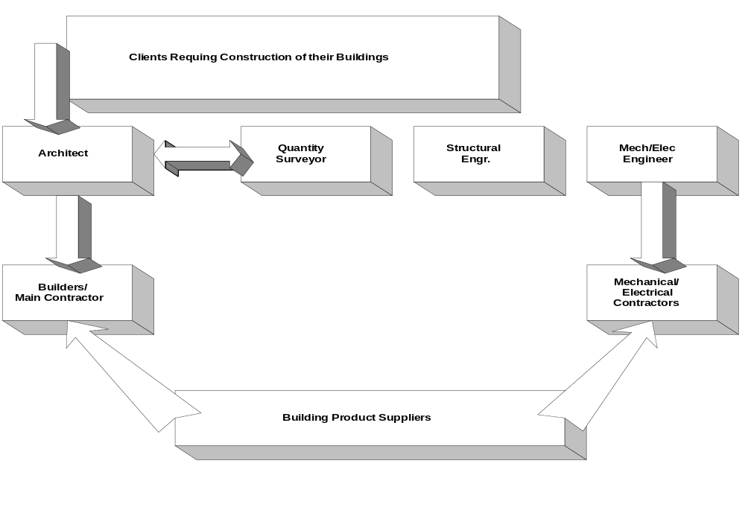

S.W.O.T. Analysis

STRENGTHS

The promoters have a long track record within the building industry and have been encouraged by the level of support which they have received from the major builders and steelwork manufacturers. Since reputation within the industry is extremely important this will contribute greatly to securing new customers, in line with this planned project.

The company enjoys a favourable location situated on the site of one of the
largest industrial sites in North Dublin close to the city centre, and the proposed M50 motorway.

The promoters have a proven track record in their ability to produce, on time and to budget the specialist products as required by our customers and recognise the importance of meeting deadlines within the overall context of construction projects.

WEAKNESSES

Financial resources are limited, but this Business Plan details the requirements and sources from which it is anticipated funding, in addition to the promoters’ input, will be forthcoming. As a result of which the company will be adequately funded to meet the requirement of the objectives as detailed elsewhere in this submission.

OPPORTUNITIES
While the immediate plan to achieve targets as identified is confined to the Dublin - Leinster region for the first two years of operation it is intended to expand into the 26 counties after our establishment in the marketplace and this will position us to cater for the whole market valued at €5.3 million nationally.

In the medium term it is intended to expand market opportunities into Northern Ireland and in the long term into Britain and mainland Europe.

THREATS
The single greatest threat to the company is that of opportunity loss in terms of the extent of business being lost due to our current non-trading. This results in orders being lost to smaller competitors who are being afforded the business, thereby becoming larger and greater competition.

MARKET STRATEGY

In order to achieve our Sales Target as per the enclosed projections the following strategy has been devised :

Objectives.
- To achieve a profitability of 5 % return on sales by year 1.
- To achieve a 8 % share of the identified market by the end of year 2.
- To achieve a profitability of 15 % return on sales by year 2.
- To secure ISO 9000 accreditation in the short term.
- Medium Term - to buy its own premises in the Dublin area.

Product.
The specialist steel products are manufactured from steel sections readily available from several sources locally. The sizes, specifications and configuration of these components varies widely from customer to customer and depends very much on the type of construction and method of jointing to be employed on the project. However, the methods of manufacture and finish are similar to all and the workshop and skilled workforce are set up to cater for this purpose.

Typical Metal/bracket drawing details are contained in the Appendices.

Price.
Currently products are being supplied into the industry at €650 per tonne, by the existing large steelwork manufacturers.

The Metal Engineering set-up for quality batch production, can manufacture and supply for this selling price and with the use of modern scheduling techniques, ensuring timely deliveries, can make its desired contribution and profit targets. Details on costing and overheads are given in Section No.7 - ‘Costings and Finance’.

Place.
Selling is carried out on a direct basis with buyers, engineers and project managers within the organisations of our customers (Builders and Precast concrete and steelwork manufacturers). This function will be carried out by our Sales and Marketing Director who will spend a large proportion of his time engaged in visits to customers promoting the company.

Place.
Contd.

The products, as described above, will be manufactured in our own workshop, to the individual design of our customers.

Deliveries post production will be made by contracted transport in two ways:
- To concrete/steelwork manufacturers
- Directly to building sites.

The products are then incorporated into building structures either by casting into concrete products during manufacture or by bolting/welding into on-site structures.

Promotion.

An initial Launch of the company is planned to take place in the Institution of Engineers of Ireland to which all the major Builders and Steelwork Manufacturers will be invited. This launch will directly target our customers very specifically and will immediately put METAL Engineering in the market.

Thereafter it is intended to carry on the sales function as described above.

ORGANISATION/ MANAGEMENT

The Organisation
Metal Engineering Limited is a private limited company with all the shares owned in equal measure by the three primary promoters.
A copy of the Certificate of Incorporation is appended and a copy of the Memorandum and Articles of Association will be made available to the Bank in the normal course.

Management Overview
Key Staff and their activities.

The combined expertise of the primary promoters has allowed for a ‘natural’ division of responsibilities as detailed hereunder:

C. Done, Director

Operations and Engineering Management.
10 Years manufacturing experience
Production scheduling
Work assignment
Health and Safety, Training, Quality Control
Resource allocation
People management

A. Cane, Company Secretary

Administration and Control.
Assistant Manager in ZZZ Group
Certified Diploma in Accounting and Finance (ACCA)
Dip. In Personnel Management.

B. Bloggs, Managing Director

Sales, Marketing.
20years experience in building industry (Project Management)
Diploma in Environmental Services Engineering.
Self employed for 17 years.

Full Curricula Vitae for the promoters are included in the Appendices.

Staff Requirement.

Year 1 Year 2

Directors 3 3

Steel fabricators 2 3

Apprentice fabricators 2 3

Semi-skilled 0 1

------- ------
Total : 7 10

Fabrication staff will be recruited from within the industry and will be time-served qualified steel fabricators/boiler makers with a minimum of five years post-apprenticeship experience.

Apprentices will be recruited and will be required to participate in on-the-job training and to take part in the national apprentice training schemes and examinations as run by FÁS. It is intended to offer permanent positions to suitable apprentices on completion of their training.

PRODUCTION AND OPERATIONS

Premises :

Metal Engineering Ltd., will commence operations within the JJJJ Concrete Ltd (Road - Also a Major customer.) concrete production facility on the North Road.

This location comprising 4,000 sq. ft. has sufficient capacity to cater for the plans as detailed in this document and will be sufficient for the foreseeable future.

A medium term goal of the Company is (5 yrs.) to buy a larger more modern premises in the Swords area.

The existing workshop requires some capital improvement in terms of additional lighting, office and canteen accommodation. Given the company’s ambition to own their own premises in the medium term, it is intended that this additional accommodation be provided by means of “portocabin” type temporary buildings.

Three-phase electrical power is available within the workshop and is adequate for the needs of the proposed plant and equipment installation.

A small secure and fire-proofed store will be required for the safe storage of paint products and thinners.

The capital expenditure requirement is included in the financial projections appended.

Health & Safety/Employment and Tax Legislation.
The promoters are very aware of the provisions of the Health, Safety and Welfare at Work Act, 1989 and of the hazards present in a fabrication facility such as that proposed here. The promoters will be preparing a Safety Statement which will be implemented and will ensure safe working practices and environment for all staff.

The various provisions under Employment legislation, Working Time Directive etc. are known to the promoters and will be adhered to by the company. Each employee will be given a contract of employment upon recruitment and proper books and tax returns will be maintained.

Insurances.
The promoters have taken advice on insurance provisions as required. Items such as Employer liability, Public Liability, Fire and All Perils insurance etc. have been costed and are covered in the projected financial statements appended.

Plant and Equipment.
The fabrication workshop will be fitted out with the following plant and equipment:

1No CO₂ Automatic welding machine.
2No. Electric arc welding machines.
3No. magnetic drills and a Pedestal Drill.
85 ton and 45 ton Iron workers - Notching and Punching machines.
Auto band saw and Pull-down band saw.
2no. Oxy/acetelene welding/burning sets.
1No. Linishing machine.
Fork lift truck.
Threading machine (To 50mm bar dia.).
A 2ton table lift.
Misc. Electric hand tools (Grinders etc.).
Misc. Jigs and small hand tools.

Production/Operations
The sequence of events leading to an order closely follows that which is practised in many ‘jobbing’ industries and would take the following steps:

An Enquiry, usually in the form of drawings and technical specification, is received and an Estimate is prepared on the basis of measured materials, labour and overhead/profit margin required. A detailed Quotation is prepared and submitted to the customer.

Upon receipt of an Order the job is Scheduled for production through the workshop. Such elements as; materials deliveries; availability of labour and customer delivery date are taken into account during this process.

The job is then put through the Fabrication shop and the various processes (Notching, punching, welding etc.) are carried out. Finished products are then cleaned and two coats of steel primer paint is applied by hand. In some cases steel products are required to be galvanised. This process will be subcontracted to TTT Ltd. in Dublin.

The job is then Delivered by subcontracted transport.

The fabrication shop is set-up to cater for both Batch and ‘One-off’ job production applications.

Quality Control.
To secure ISO 9000 accreditation for the manufacturing process as described above. The promoters have experience in the implementation of this standard elsewhere and will be writing procedures to accommodate a quality audit prior to commencement of production.

In some instances particular products may require test & inspection procedures of a structural nature. These destructive tests and certification processes are carried out by the state testing centre at Eolas in Glasnevin. The tests are at the particular request of customers and are paid for as an extra-over to the manufacturing contract.

COSTINGS / FINANCE

Assumptions to the Financial Projections.

Full sets of financial projections for the first two years of operation are contained in the Appendices.

Sales
The sales as projected for the first year, based on direct primary research of our potential customers, are set at:
Year 1: 5% of target market.
Year 2: 10% of target market
The projected sales are modest given the extent of the potential market of €5.3 million and our research indicates that these figures are achievable.

Expenses
Full schedule of expenses is contained in the appended projections. The expenses as calculated are realistic and based on current prices.

Detailed Job Costing Overview
Full analysis of the Labour Rate build-up are given in the Appendices and the Unit Sales / average job costing make up is as follows:

Unit Pricing per Tonne.

Labour €140
Materials €280

Total Direct costs: €420

Market Selling Price €650

Contribution €230 per tonne production.

It is necessary to base costings on a unit cost per tonne production in order to cater for the diversity in type of product being manufactured, This unit cost is used throughout the industry.

Capital Grant
It has been assumed that the full Capital Grant of IR€13,505 is received by the project in the month succeeding the expenditure. We are confident that this sum will be available based on initial discussions with the County Enterprise Board. They have confirmed that the provision of IR€1,930 per job represents very good value for the creation of 7 new jobs in the industry.
Capital Expenditure
It has been assumed that the capital expenditure, in the amount of IR27,010, occurs in the month preceding operations, but for clarity this has been shown in Month 1.

A full schedule of projected Capital Expenditure is appended.

Funding:
It is intended to fund the proposed project as follows:

Use of Funds:
Capital Expenditure € 27,010
Working Capital € 31,495
----------
€ 58,505

Source of Funds:
Promoters’ funds € 15,000
Bank Term Loan € 20,000
Bank Overdraft € 10,000
CEB Grant € 13,505
-----------
€ 58,505

Credit Terms
The ‘industry norm’ for credit (debtors and creditors) is 60days and the projections follow this norm.

Sensitivity Analysis
A sensitivity analysis for Year 1 has been included in the appendices and this shows the following:
Year 1
As Projected Sales - 10% Sales -20%

Cash Balance € 2,036 (€ 3,531) (€ 8,291)
Profit (Loss) € 13,919 € 4,468 (€ 1,387)

The promoters are satisfied that the projected profit of 5% for the first year is achievable and has been conservatively calculated. However, the sensitivity analysis shows that the company can reasonably survive a shortfall in sales of up to 20% in the first year and have purposely set their working capital requirement at the levels indicated in order to cater for such an unlikely event.

Inflation
Given the current financial climate, inflation has been ignored for the purposes of this business plan.

APPENDICES

Appendix A Financial Projections - Yr.1 and Yr.2
Profit and Loss; Cash flow
Balance Sheet

Appendix B Certificate of Incorporation.

Appendix C Tax Clearance Certificate

Appendix D Promoters’ C.V’s.

Appendix E Equipment Schedule.

Appendix F Typical Product Drawings.

Appendix G Project Start Programme.

